Labaratoriya 10

CSS transition va animatsiya elementlarini yaratish

KIRISH
Zamonaviy veb-saytlar foydalanuvchi tajribasini (UX) yaxshilash va interfeysni jozibador qilish uchun turli dinamika va vizual effektlardan foydalanadi. Shunday vositalardan biri – bu CSS transition va animatsiya texnologiyalari.
Transitionlar elementdagi o‘zgarishlarni yumshoq o‘tish bilan amalga oshirsa, animatsiyalar esa elementga murakkab, ketma-ket va avtomatik harakatlar berishga imkon yaratadi. Ushbu mavzu veb-dizayn, UI/UX, front-end dasturlashda juda muhim o‘rin tutadi.
ASOSIY QISM

1. CSS Transition tushunchasi
Transition – element holati o‘zgarganda (masalan hover, focus, active) sodir bo‘ladigan o‘tish effektidir. Bu jarayonda o‘zgarishlar birdaniga emas, balki ma’lum vaqt davomida asta-sekin amalga oshadi.

Transitionning asosiy xossalari:
transition-property – o‘zgartiriladigan xususiyat
transition-duration – davomiylik
transition-timing-function – tezlikning taqsimlanishi
transition-delay – kechikish

Misol:
.box {
width: 100px;
height: 100px;
background: blue;
transition: all 0.5s ease;
}
.box:hover {
background: red;
width: 150px;
}
Ushbu kodda elementga hover qilinganda rang va o‘lcham 0.5 sekund ichida asta-sekin o‘zgaradi.

2. CSS Animation tushunchasi
Animation – elementda bir necha bosqichdan iborat harakatlarni bajarish imkonini beruvchi kuchli vosita. Transitiondan farqli ravishda animatsiya avtomatik ishlashi mumkin va o‘zgarishlar bir nechta bosqich orqali belgilanadi.

Animationning asosiy elementlari:
@keyframes – animatsiyaning bosqichlari (0%–100%)
animation-name
animation-duration
animation-iteration-count
animation-direction
animation-fill-mode
animation-delay

Misol:
.ball {
width: 50px;
height: 50px;
background: green;
border-radius: 50%;
animation: move 3s infinite;
}
@keyframes move {
0% { transform: translateX(0); }
50% { transform: translateX(200px); }
100% { transform: translateX(0); }
}
Bu animatsiya doirani chapdan o‘ngga harakatlantiradi va doim takrorlanadi.

3. Transition va Animation o‘rtasidagi farqlar
Transition | Animation
Holat o‘zgarganda ishga tushadi | Mustaqil ishlashi mumkin
Oddiy o‘tishlar uchun | Murakkab harakatlar uchun
Keyframes talab qilinmaydi | @keyframes talab qilinadi
Hover, focus kabi holatlarga bog‘liq | Avtomatik yoki trigger bilan ishlaydi

4. Amaliy qo‘llanilishi
tugmalar hover effektlari
menyular ochilishi
rasm ustida zoom effektlar
loaderlar (aylanish, sakrash)
banner animatsiyalari
ikonkalarning jonlanishi
Transitionlar asosan UX uchun zarur bo‘lsa, animatsiyalar veb-dizaynni jonlantirish va foydalanuvchi diqqatini jalb qilish uchun ishlatiladi.
Amaliy qismi:
<!DOCTYPE html>
<html lang="uz">
<head>
<meta charset="UTF-8">
<title>Gul Do‘koni — Transition va Animatsiya</title>

<style>
body {
margin: 0;
font-family: 'Poppins', sans-serif;
background: linear-gradient(135deg, #fff3e0, #fce4ec);
}

header {
text-align: center;
padding: 30px;
background: #c2185b;
color: white;
border-bottom-left-radius: 25px;
border-bottom-right-radius: 25px;
}

h1 {
margin: 0;
font-size: 38px;
}

.section {
max-width: 1100px;
margin: auto;
padding: 40px;
}

.items {
display: grid;
grid-template-columns: repeat(3, 1fr);
gap: 25px;
}

.item {
background: white;
border-radius: 20px;
overflow: hidden;
box-shadow: 0 6px 16px rgba(0,0,0,0.15);
transition: transform 0.4s ease, box-shadow 0.4s ease;
}

.item:hover {
transform: translateY(-12px) scale(1.05);
box-shadow: 0 12px 28px rgba(0,0,0,0.25);
}

.item img {
width: 100%;
height: 220px;
object-fit: cover;
}

.content {
padding: 15px;
}

.title {
font-size: 22px;
margin: 0;
color: #880e4f;
}

.type {
margin-top: 4px;
font-weight: bold;
color: #d81b60;
}

.desc {
color: #4e342e;
margin-top: 8px;
}

.animation-title {
text-align: center;
margin-top: 60px;
font-size: 30px;
color: #ad1457;
}

.anim-area {
display: flex;
justify-content: space-around;
padding: 40px 0;
flex-wrap: wrap;
}

@keyframes moveFlower {
0% { transform: translateX(0); }
50% { transform: translateX(80px); }
100% { transform: translateX(0); }
}
.flower-move {
width: 140px;
animation: moveFlower 2.5s infinite ease-in-out;
}

@keyframes bloom {
0% { transform: scale(1); }
50% { transform: scale(1.2); }
100% { transform: scale(1); }
}
.flower-bloom {
width: 160px;
animation: bloom 1.6s infinite;
}

@keyframes rotateFlower {
0% { transform: rotate(0); }
100% { transform: rotate(360deg); }
}
.flower-rotate {
width: 140px;
animation: rotateFlower 4s infinite linear;
}

@media (max-width: 700px) {
.items {
grid-template-columns: 1fr;
}
header h1 {
font-size: 30px;
}
.anim-area {
flex-direction: column;
align-items: center;
gap: 30px;
}
}

@media (max-width: 1000px) {
.items {
grid-template-columns: repeat(2, 1fr);
}
}
</style>
</head>
<body>
<header>
<h1>🌸 Gul Do‘koni — Transition & Animation</h1>
<p>CSS effektlari asosida yaratilgan nafis dizayn</p>
</header>

<section class="section">

<h2>💐 Gullar — Transition bilan kartochkalar</h2>

<div class="item">
<img src="rasim 2" alt="">
<div class="content">
<h3 class="title">Atirgullar Guldastasi</h3>
<p class="type">Romantik gullar</p>
<p class="desc">Sevgi va mehr ramzi bo‘lgan qizil atirgullar to‘plami.</p>
</div>
</div>

<div class="item">
<img src="rasim 3.jpg" alt="">
<div class="content">
<h3 class="title">Lola Guldastasi</h3>
<p class="type">Bahor gullari</p>
<p class="desc">Bahor kayfiyatini ulashuvchi rang-barang lolalar.</p>
</div>
</div>

<div class="item">
<img src="rasim 4" alt="">
<div class="content">
<h3 class="title">Orxideya</h3>
<p class="type">Nafis gul</p>
<p class="desc">Hashamatli va uzoq saqlanadigan orxideya guli.</p>
</div>
</div>

<div class="item">
<img src="rasim 5.jpg" alt="">
<div class="content">
<h3 class="title">Aralash Guldasta</h3>
<p class="type">Bayram uchun</p>
<p class="desc">Turli gullardan iborat yorqin va chiroyli guldasta.</p>
</div>
</div>

<div class="item">
<img src="rasim 6.jpg" alt="">
<div class="content">
<h3 class="title">Xonaki Gullari</h3>
<p class="type">Dekoratsiya</p>
<p class="desc">Uy va ofislar uchun yashil va parvarish oson gullar.</p>
</div>
</div>

<div class="item">
<img src="rasim 7.webp" alt="">
<div class="content">
<h3 class="title">Gul Qutilari</h3>
<p class="type">Sovg‘a variant</p>
<p class="desc">Zamonaviy dizayndagi qutilarda joylangan gullar.</p>
</div>
</div>

</section>

</body>
</html>

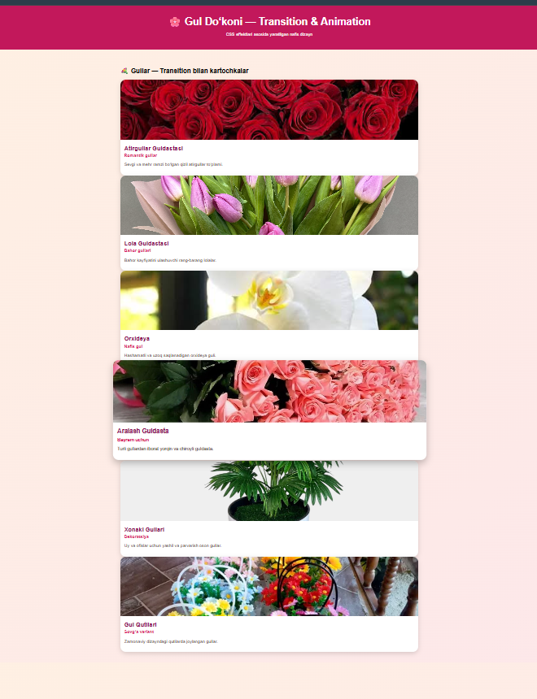

XULOSA
CSS transition va animation — frontend ishlab chiqishda juda muhim texnologiyalar bo‘lib, ular yordamida veb-sahifaga joziba, dinamika va professional ko‘rinish berish mumkin. Transitionlar kichik va yumshoq o‘tishlar uchun qulay bo‘lsa, animatsiyalar murakkab harakatlar, bannerlar va jonli effektlar yaratish imkonini beradi. Ushbu texnologiyalarni puxta o‘rganish dizayner yoki dasturchiga interfeysni yanada qulay, jozibador va interaktiv qilishi mumkin.

